Instruction Manual for Magnetic Stirrer DSMS-100
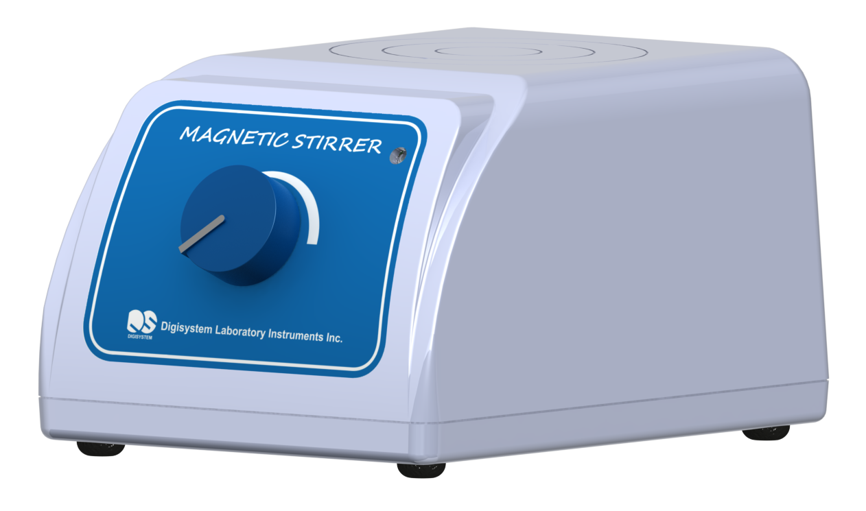
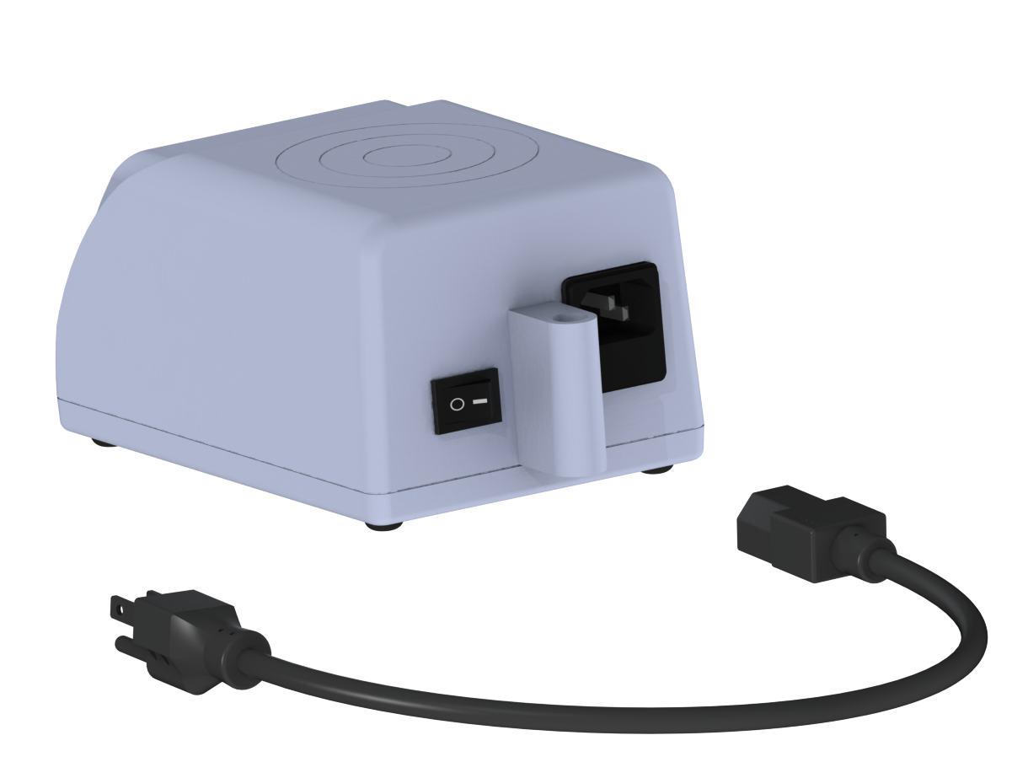
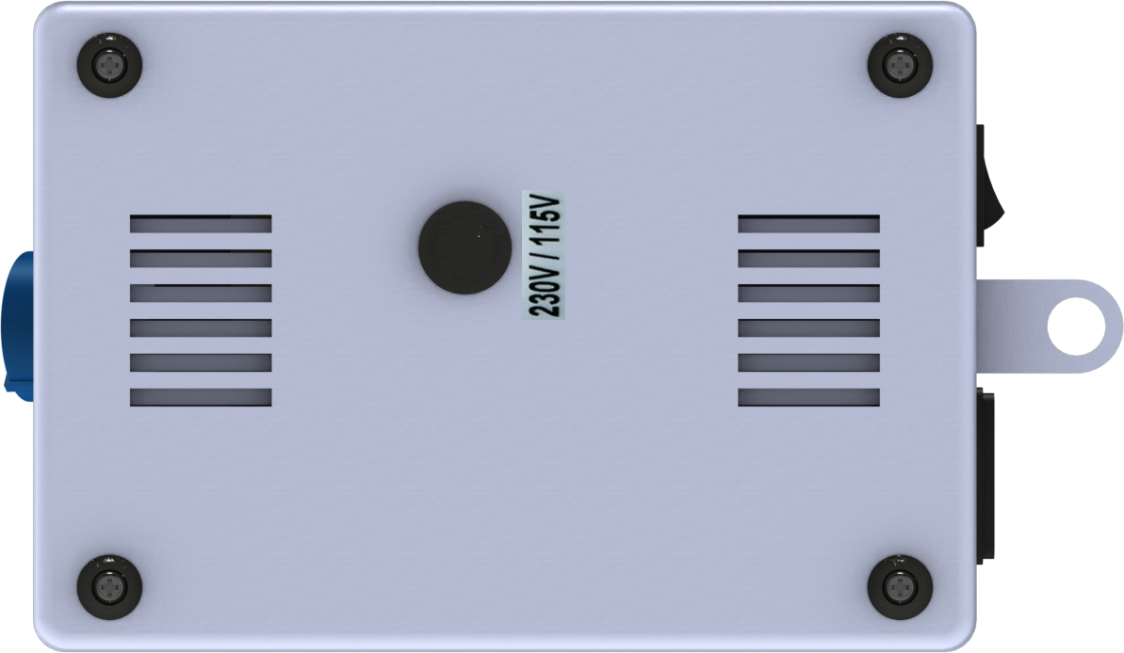
(5)
(6)
(3)
(8)
(4)
(7)
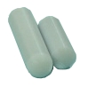
(1)
(2)

Name of part:
- Power cable (2) Power cable inlet (3) Stirring bar (4) Power switch (5) Power indicator
(6) Speed control knob (7) Plug (8) Fuse holder

Specification:
Speed: 150~2000rpm; Stirring capacity: 100~2000ml; Motor: DC motor; Total wattage: 3W;
Power: 115V / 230V (with a switch), 50/60Hz; Accessory: 1pc x 2.5cm stirring bar, 1pc x 4.0cm stirring bar

Warnings:
* Do not disassemble the instrument by yourself. In the event of a malfunction, the instrument should be repaired by a qualified technician. Before repairing, turn off the power and disconnect the power cable.

1. Place the magnetic stirrer on a flat surface. Make sure the Power switch is in the off position.
2. Insert the Power cable into the Power cable inlet, and then plug the instrument into a properly grounded outlet .
3. Put one Stirring bar into a container with solutions. Place the container on the center of the top surface of the instrument. Make sure the stirring bar is at the center of the container.
4. Turn on the Power switch. Then the Power indicator is illuminated.
5. Turn the Speed control knob clockwise to set the desired stirring speed.

Note: Before shipment, the power voltage will be set as requested. If the instrument will be used at a different place with a different voltage, please remove the Plug at the bottom of machine, and use a pen (or a stick) to adjust the switch to be 115V or 230V.

Circuit Diagram
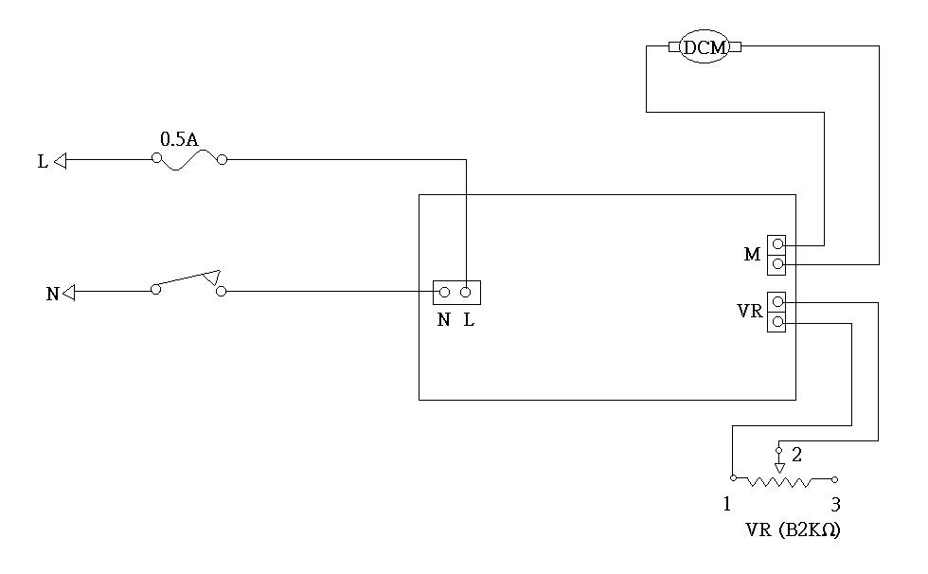

Troubleshooting Guide
Caution: Always disconnect the power cable before troubleshooting.
Trouble | Cause | Remedy
Instrument inoperative  (Power indicator is not illuminated) | Power cable is not securely connected. | Reconnect it securely.
Instrument inoperative  (Power indicator is not illuminated) | Fuse is burnt. | Replace a new fuse.
Instrument inoperative  (Power indicator is not illuminated) | Dead outlet. | Change to different a outlet
Instrument inoperative  (Power indicator is not illuminated) | Defective electronic component. | Contact your distributor for repair.
Fuse is burnt | Wrong power source. | Replace a new fuse. Supply the correct power source, or adjust the switch (at the bottom) to the correct voltage (115V or 230V).
Instrument does not operate. (Power indicator is illuminated) | Defective motor. | Contact your distributor for repair.
 | Defective PC board. | Contact your distributor for repair.
Speed can not be controlled | Defective PC board. | Contact your distributor for repair.
Speed can not be controlled | Variable resistance is broken. | Contact your distributor for repair.
Stirring bar can not rotate in the solution. | The container and the stirring bar are not be placed at the center of the top surface of instrument. | Replace the container and stirring bar correctly.

